DAVID FOURNEY, PH.D.

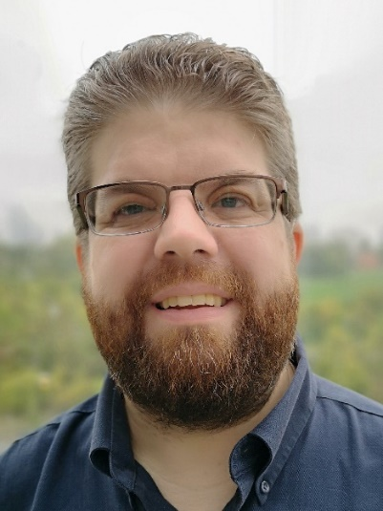

David Fourney is an IT Accessibility Consultant based in Toronto, Canada with extensive experience in digital accessibility and inclusive design. David holds the CPWA designation, the highest certification for accessibility professionals, issued by the International Association of Accessibility Professionals. IAAP is a division of G3ict.

Dr. Fourney has earned a Ph.D. in Industrial Engineering from Ryerson University and degrees in Computer Science and Psychology from the University of Saskatchewan. His research interests include accessible media and entertainment, methods for inclusive design, and improving the usability and accessibility of information and communications technologies (ICT) for all users.

He has always possessed a strong passion for the field of accessibility that largely stems from his own experiences as a neurodiverse hard of hearing person as well as his efforts towards raising awareness and advocating for himself, and others with disabilities, starting early on in his life.

For over 15 years, Dr. Fourney has been involved in the development of international standards in accessibility, human factors / ergonomics, and user interfaces through the International Organization for Standardization (ISO). He led the development of an international standard in the presentation of auditory information through technologies such as captioning. He is also the International Convenor and a founding technical expert of an ISO working group on haptics. As a Canadian technical expert, David was involved in the development of ISO 9241-171, an international standard on software accessibility that influenced the development of WCAG 2.0.

He has also been involved with the activities of various Canadian disability organizations including the National Educational Association of Disabled Students (NEADS) and Silent Voice Canada. He is a lifelong member of the Canadian Hard of Hearing Association (CHHA).

Dr. Fourney is joining the standardization process at ITU-T as a person with a disability to extend and expand his ongoing work, often based on his own research, in the standardization community as well as providing a consumer perspective as both a disabled consumer of the products and a professional consumer of the standards.

