LIDIA BEST
VICE CHAIRMAN of ITU JCA-AHF (INTERNATIONAL TELECOMMUNICATION UNION JOINT COORDINATION ACTIVITIES ON ACCESSIBILITY AND HUMAN FACTORS)
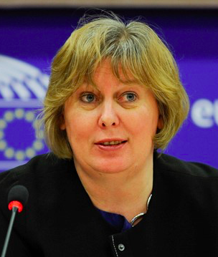
Lidia is a Vice Chairman of ITU JCA-AHF (International Telecommunication Union Joint Coordination Activities on Accessibility and Human Factors) and internationally recognised accessibility expert and advocate for persons who are deaf or hard of hearing. She brings unique knowledge as expert with lived experience, as a person who is hard of hearing and a cochlear implant user since 2009.

Her work has specific focus on accessibility and quality of hearing care for deaf and hard of hearing people including policy development, training, and consulting. She contributed to work on standards as a member of G3ict delegation to ITU in telecoms, captioning and assistive listening devices, having authored the ITU FSTP-RCSO “Overview of remote captioning services" and H.871“Safety requirements for wearable audio augmenting devices” the recommendation on personal sound amplifiers.

After 10 years, Lidia stepped down from her position of the Vice-President of the EFHOH (European Federation of Hard of Hearing) in 2020 to concentrate on international advocacy work which includes WHO World Hearing Forum. While at EFHOH, she was co-author of reports into situation of hard of hearing and deafened people in Europe in areas of employment, hearing care and accessibility.
In UK, Lidia is a Chairman of the National Association of Deafened People (NADP).

