ANDREW SAM

Adaptive Technologist, Disability Rights Unit, University of the Witwatersrand (Wits), South Africa

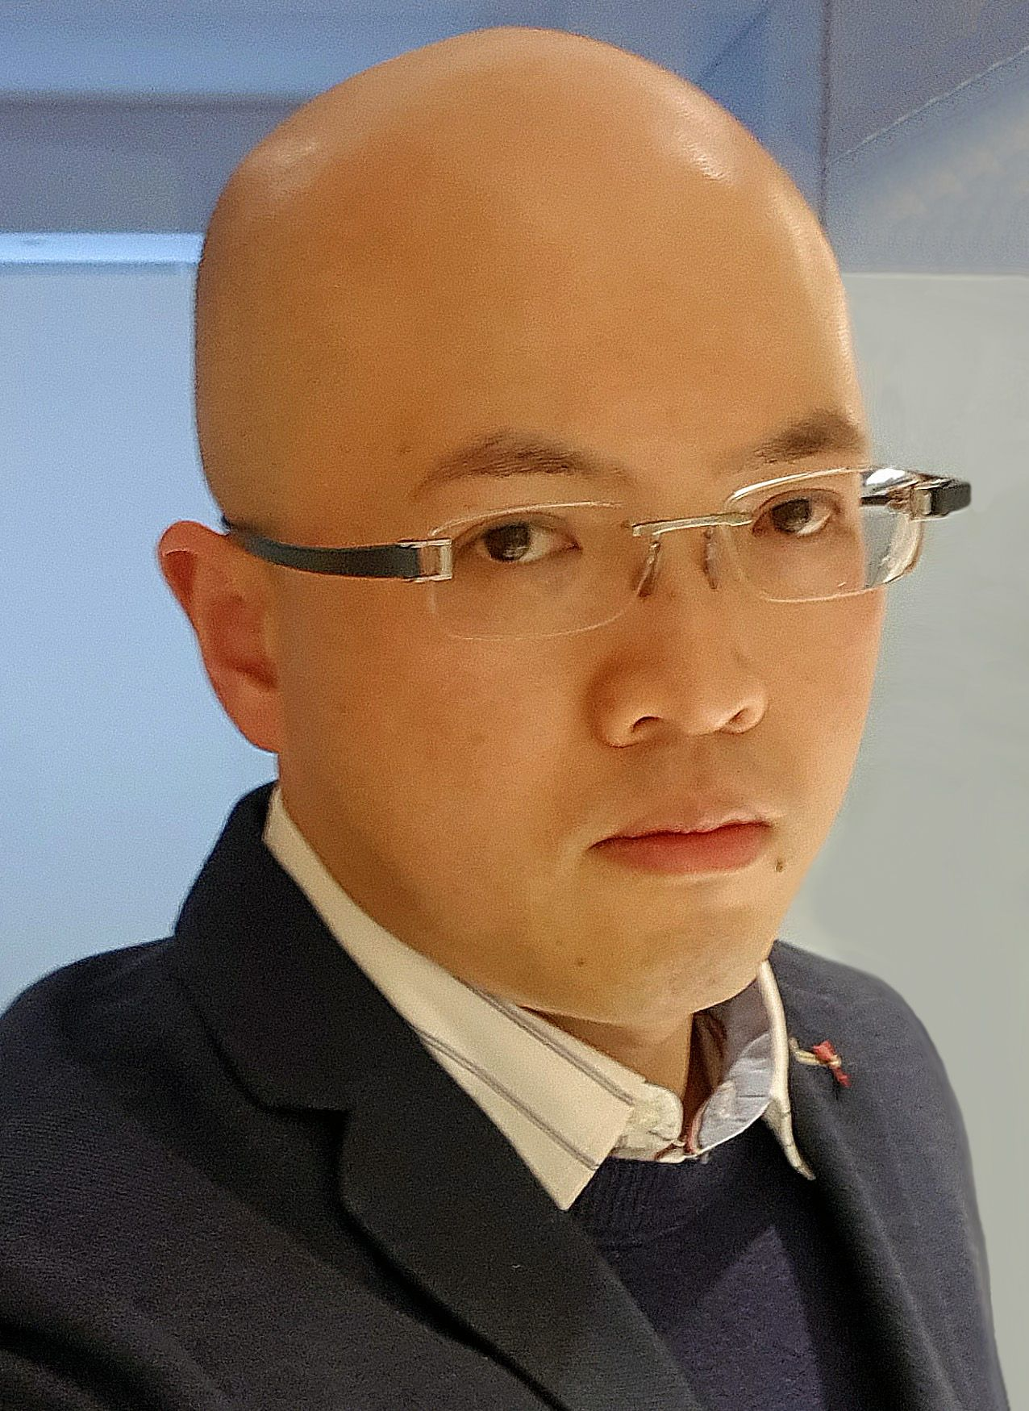

Andrew Sam is an Adaptive Technologist for the Disability Rights Unit at the University of the Witwatersrand in Johannesburg, South Africa. He is a Network Systems Engineer with a Bachelor of Science degree, with over 18 years of experience training and supporting students with assistive technology.

