DAREEN ABU-LAIL

OUTREACH ACCESSIBILITY MANAGER, STUDENT ACCESSIBILITY SERVICES, ZAYED UNIVERSITY

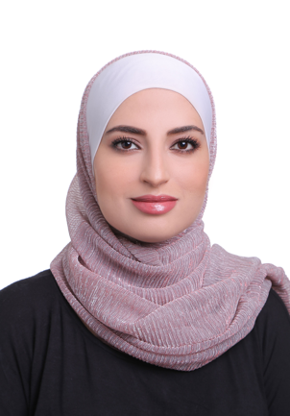

Dareen Abu-Lail is the Accessibility Outreach Manager in the Department of Student Accessibility Services (SAS) at Zayed University in the United Arab Emirates. Ms. Abu-Lail is an MBA in Leadership and Sustainability holder with more than 12 years of experience in community outreach and social responsibility programming. Believing in SAS mission to ensure equitable education for all Students of Determination, Ms. Abu-Lail contributes to promoting inclusivity, diversity and accessibility in the higher education and thereby, fulfilling SAS vision in cultivating Graduates of Determination that are socially, technically and academically equipped to join the Emirati workforce on an equal filed with their peers.

