MARCIA LYNER-CLEOPHAS, Ph.D.

HEAD OF THE DISABILITY UNIT,

STELLENBOSCH UNIVERSITY, WESTERN CAPE

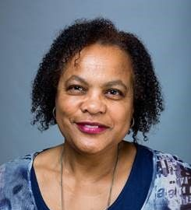

Dr Marcia Lyner-Cleophas is an educational psychologist and manages the Disability Unit at Stellenbosch University, Western Cape, South Africa. She works in higher education as a reflective practitioner in the field of disability inclusion, and previously worked at the Noluthando School for Deaf learners and in a high school. She is an active member of the Higher and Further Education Disability Services Association (HEDSA) and publishes about disability inclusion and finding creative ways to leave no person behind, including students with disabilities.

