MIKHAIL MOZGOVOY, Ph.D.

DEPUTY DIRECTOR, EDUCATIONAL, RESEARCH AND METHODOLOGICAL CENTER FOR VOCATIONAL REHABILITATION FOR PERSONS WITH DISABILITIES, BAUMAN MOSCOW STATE TECHNICAL UNIVERSITY

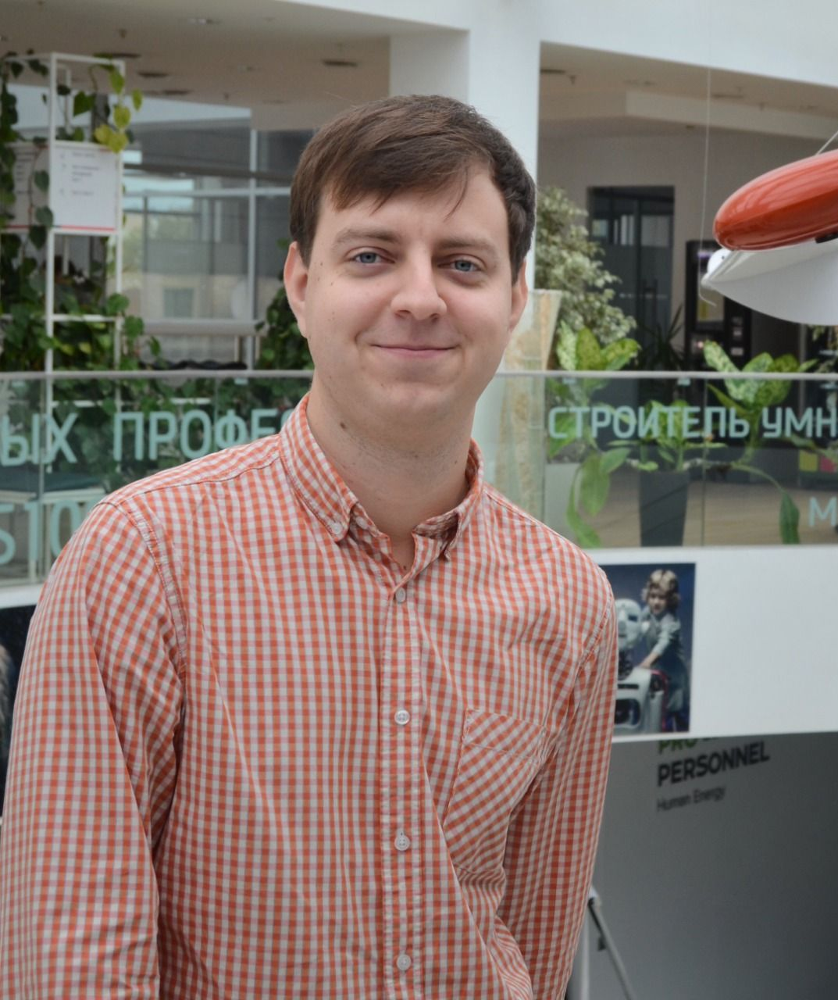

Mikhail Mozgovoy is a Deputy Director of The Educational, Research and Methodological Center for Vocational Rehabilitation of Persons with Disabilities at Bauman Moscow State Technical University (Russian Federation).
He manages the organization of the educational process and support for more than 150 students with disabilities at BMSTU.
Member of the Coordinating Council for the Disabled of the All-Russian People's Front.
He has two degrees from BMSTU in "Information and Management Systems" (2011) and "Linguistics" (2015). At the moment he is studying for a master's degree at the Higher School of Economics in the program "Digital Transformation of Education" (2022).
Having almost 10 years of experience in this field.his area of scientific and professional interests is assistive and information technology in education, technical means of rehabilitation, social entrepreneurship.

